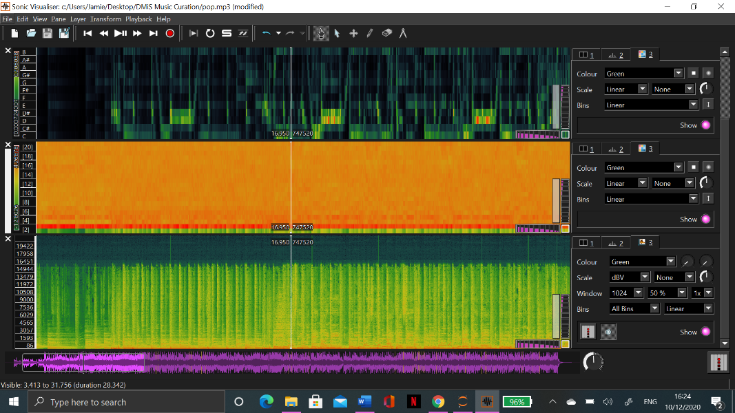

Pop

Dance

Blues

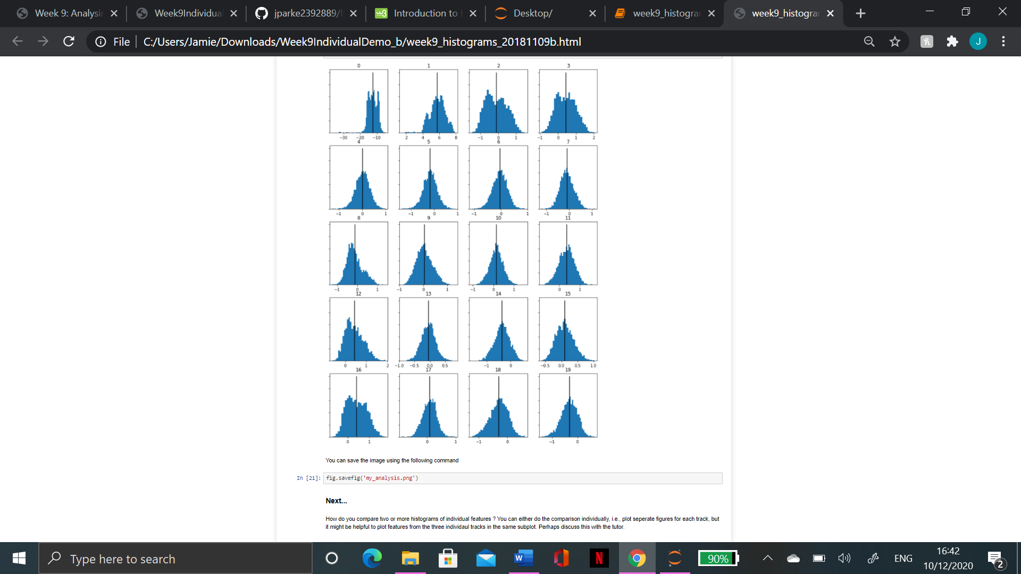

This is my histograms based of my chromas. This conveys just how different the tracks truly are when compared using this format. If you look at the different, especially with number 0, you can see that there is a lot of variation which can be heard within the tracks.